
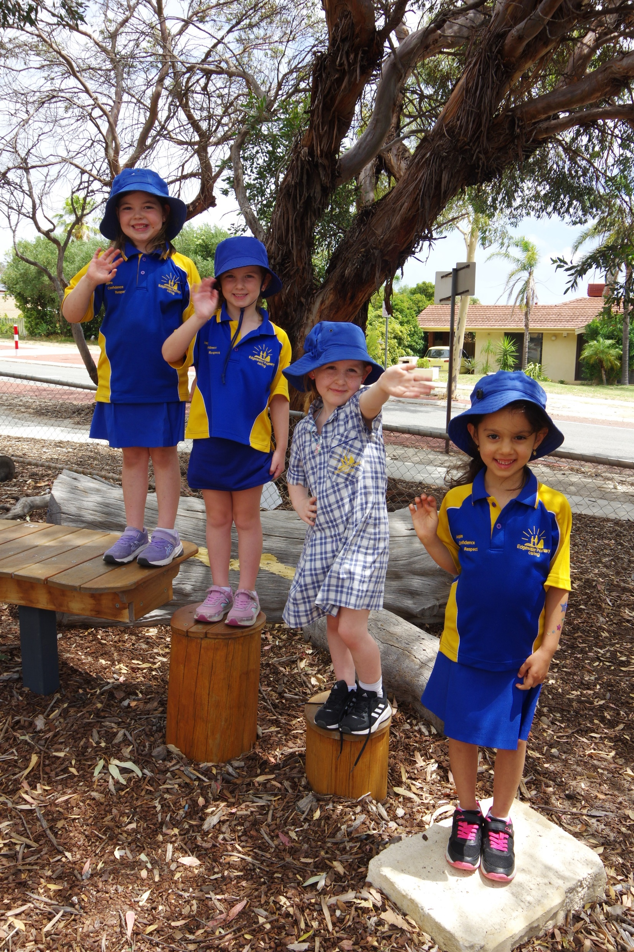
F
ASPIRE • CONFIDENCE • RESPECT
INFORMATION BOOKLET 2025

CONTENTS

PRINCIPAL’S INTRODUCTION 5
OUR VISION 5
OUR BELIEFS 5
EDGEWATER PRIMARY SCHOOL LEADERSHIP TEAM 6
SCHOOL STAFF 6
SCHOOL BOARD 8
PARENTS AND CITIZENS’ ASSOCIATION (P&C) 8
SCHOOL TERMS 9
SCHOOL DEVELOPMENT DAYS (Students do not attend) 9
PUBLIC HOLIDAYS 9
SCHOOL TIMES 9
ABSENCES/ATTENDANCE 10
Accidents/Sick Children 10
Allergies 10
App (Iphone AND aNDROID) 10
Assemblies/Ceremonies 11
Bicycles 11
Bushfire Plan 11
BYOD (Bring Your Own Device) 11
Camp – Year 6 11
Canteen 12
Chaplain 12
Communicable Diseases 12
Communication with Parents/Carers 12
Computers/ICT 13
Contact Details 13
Contact with School Staff 14
Contributions & Charges 14
Dental Clinic 14

Dogs on School Grounds 15
ENROLMENT 15
Excursions/INCURSIONS 15
Excursion/INCURSION Costs 15
Factions 15
First School Morning 15
Head Lice (Pediculosis) 16
Homework 16
Immunisation 16
Languages 16
Late/Leaving School 17
Library Resource Centre 17
Lost Property 17
Lunch 17
Medication 17
Merit Certificates 18
Mobile Phones and Other Electronic Devices 18
Money 18
Music/Choir 18
NAPLAN (National Assessment Program – Literacy and Numeracy) 18
Newsletters 19
No Hat, No Play 19
Office Opening Hours 19
Out-oF-School-Care 19
P&C Association 19
Parent Involvement 20
Parent/Teacher Interviews 20
Parking 20
Personal Use Items 21
Physical Education 21
Pick Up Delays 21
Play Equipment 21
Playground Supervision 21

Psychologist (Student Welfare) 211
Reporting to Parents 22
Safety House Scheme 22
SCHOOL BOARD 22
School Grounds 23
School Nurse 23
School Photos 23
School Rules 23
Security - School Watch 24
Signing Out 24
Smoking 24
Special School Programmes 24
Sports and Faction Athletics Carnival 24
Student Assessment and Evaluation 25
Student Council and Faction Captains 25
Student Leadership 25
Swimming Lessons 25
Telephone Messages 25
Term Planner 25
Transfers to and from other Schools 25
Uniforms 26
Visitors 26
Website 26
School Watch Freecall number 1800 177 777 27
Police Assistance number 13 14 44 27
GETTING INVOLVED 27
SCHOOL MAP 28
CHECK FOR PARENT VOLUNTEERS IN SCHOOLS………………………………………………………………29

PRINCIPAL’S INTRODUCTION
Welcome to a new year at Edgewater Primary School.
Our experienced, caring staff are committed to working collaboratively with parents/carers to provide a holistic education that allows each child to realise their potential.
As an Independent Public School, we seek to foster partnerships within our school community to enhance the quality of the education we provide, so that our students can become responsible citizens who aspire to do their very best, with confidence and respect.
If at any time you have concerns regarding your child or school operations, please contact your child’s teacher or the school leadership team.
This Information Booklet provides details of the operational aspects of our school. I trust you will find it a handy reference throughout 2025 as we look forward to a highly successful and rewarding year ahead.
Amanda Kelley

OUR VISION
In a rapidly changing world, we are committed to creating an environment where students have the opportunity and desire to become aspirational, confident and respectful learners.

OUR BELIEFS
Within the school environment, everyone has the right to feel safe, secure and valued.
All stakeholders share responsibility for learning by promoting the knowledge of the community and the well-being of all.
We are a learning community with the common goal of fostering the physical, emotional, social and cognitive domains of every child.
Everyone has the right to engage in positive learning activities.

All children have the right to learn and all teachers have the right to teach.
Successful children and staff are aspirational, confident and respectful.
All children learn and develop at different rates, and in different ways.

EDGEWATER PRIMARY SCHOOL LEADERSHIP TEAM
PRINCIPAL  ASSOCIATE PRINCIPALS  MANAGER CORPORATE SERVICES  ADMINISTRATION OFFICERS | Ms Amanda Kelley  Mrs Sadie Brayshaw  Mr Brian Baily  Ms Diana Bruce  Mrs Ashley Lewis  Mrs Karene Byrne | Amanda.Kelley@education.wa.edu.au  Sadie.Brayshaw@education.wa.edu.au  Brian.Baily@education.wa.edu.au  Diana.Bruce@education.wa.edu.au  Ashley.Lewis@education.wa.edu.au  Karene.Byrne@education.wa.edu.au

SCHOOL STAFF
Teaching Staff
Year | Room | Teachers | Email
K | K1 | Mrs Shelly Pannell  Mrs Pip Byrnes | Michele.Pannell@education.wa.edu.au Pip.byrnes@education.wa.edu.au
P/1 | P1 | Mrs Gabrielle Radford  Mrs Danielle Miraudo | Gabrielle.Radford@education.wa.edu.au  Danielle.Circosta@education.wa.edu.au
PP | P2 | Miss Melanie Tangermann  Mrs Diane Ailakis | Melanie.Tangermann@education.wa.edu.au  Diane.ailakis@education.wa.edu.au
1 | 3 | Mr Ross Tolmie | Ross.Tolmie@education.wa.edu.au
1 | 4 | Mrs Jenny Lowe | Jennifer.Lowe2@education.wa.edu.au
2 | 16 | Miss Rachel McGurnaghan | Rachel.McGurnaghan@education.wa.edu.au
2 | 15 | Mrs Maria McGrath | Maria.McGrath@education.wa.edu.au
3 | 17 | Mr Conor Richards | Conor.Richards@education.wa.edu.au
2/3 | 14 | Mr Jy Cooper | Jy.Cooper@education.wa.edu.au
3 | 11 | Mrs Tracy Rubidge | Tracy.Rubidge@education.wa.edu.au
4 | 1 | Mrs Sue Sugg  Mrs Jasmin Sevastos | Sue.Sugg@education.wa.edu.au  Jasmin.Sevastos@education.wa.edu.au
4 | 2 | Mrs Emma Leaver | Emma.Smith@education.wa.edu.au
5 | 8 | Mrs Gail Baily  Mrs Susanne Cleaver | Gail.Baily@education.wa.edu.au  Susanne.Cleaver@education.wa.edu.au
5/6 | 6 | Mr Adam Smith | Adam.Smith4@education.wa.edu.au
5/6 | 5 | Mrs Sue Safe | Susan.safe@education.wa.edu.au
Support & Specialist Teaching Staff
Visual Art |  | Ms Keira Clarke | Keira.Clarke@education.wa.edu.au
Music |  | Mr Nevad Hadzic | Nevad.Hadzic2@education.wa.edu.au
Physical Education |  | Ms Cindy Farinosi | Cindy.Farinosi@education.wa.edu.au
Science |  | Ms Di Ailakis | Diane.Milentis@education.wa.edu.au
Languages |  | Mrs Tracey Rayner | Tracey.Rayner@education.wa.edu.au

The school Leadership Team and teaching staff can also be contacted through the school office
(6207 3200) or by email at Edgewater.PS@education.wa.edu.au

Non-Teaching Staff
Special Educational Needs Education Assistants | Mrs Dawn Latham  Mrs Sue Nock  Mrs Brooke Deschamps
General Education Assistants | Mrs Karen Giacobino  Ms Lynn Hamer  Mrs Kylie Vanderwiel  Mrs Jo Russell  Mrs Trisha Varsani  Mrs Kylie Dawson
Psychologist | Mrs Kristy Mollett
Chaplain | Mrs Sara D’Uva
Library Officer | Miss Emily Butt
Gardener/Handyperson | Mr David Osborne
Head Cleaner | Mr Nick Banks
Cleaner | Mrs Manpreet Kaur  Mrs Iwoma Kopczyk

SCHOOL BOARD
Chair & Parent Representative | Grant Moriarty
Principal | Amanda Kelley
Parent Representatives | Michelle Bullen
Parent Representatives | Tracy Lombardo
Parent Representatives | Rhys Howard
Parent Representatives | Laura Dale
Parent Representatives | Tim Evans
Parent Representatives | David Williams
Staff Representatives | Di Ailakis
Staff Representatives | Sadie Brayshaw
Staff Representatives | Brian Baily
Community Representative | TBA

School Board members can be contacted through the school office at Edgewater.PS@education.wa.edu.au

PARENTS AND CITIZENS’ ASSOCIATION (P&C)
President | Sam Blake
Vice President | Elena Pimenova
Secretary | Tegan Hunt
Treasurer | Dee O’Connor
Canteen Committee Contact | Tracey Lombardo
Fundraising Committee Contact | Tegan Hunt
Graduation Committee Contact | Tegan Hunt
Safety House Contact | Meera Chokshi

P&C members can be contacted by email at Edgewater.PS.PandC@gmail.com

SCHOOL TERMS
SEMESTER 2
SEMESTER 1
Term 1: Wednesday 5 February – Friday 11 April
Term 2: Monday 28 April – Friday 4 July
Term 3: Monday 21 July – Friday 26 September
Term 4: Monday 13 October – Thursday 18 December

SCHOOL DEVELOPMENT DAYS (Students do not attend)
SEMESTER 1 | Term 2: 30 May 2025 | SEMESTER 2 | Term 3: 25 August 2025  Term 4: 7 November 2025

PUBLIC HOLIDAYS
Labour Day: Monday 3 March  Good Friday: Friday 18 April  Easter Monday: Monday 21 April | ANZAC Day: Friday 25 April  Western Australia Day: Monday 2 June  King’s Birthday: Monday 29 September

SCHOOL TIMES
NOTE: See the Early Childhood Centre Kindergarten Information Booklet for Kindy times, available on the school website.

Recess: 10:45am – 11:05am
Lunch: 1:05pm – 1:50pm

Classroom doors open: 8:30am
Commencement: 8:45am
Finish: 3:00pm

Students are expected to arrive at school between 8.30am and 8.40am. They are required to sit quietly outside their classroom until the teacher opens the classroom door at 8.30am, ready for the school day to begin at 8.45am.

A student is not permitted to leave the school grounds during school hours without prior permission.

ABSENCES/ATTENDANCE
Department of Education Regulations indicate that the only acceptable reason for absence from school is illness or associated medical appointments. The explanation for an absence must be received from the parent/carer within three days of the absence and can take the form of notification through Compass app, or email the office.
The Principal does not have the authority to approve absences for holidays, etc. An absence of this nature is the responsibility of the parent and is viewed as a parent condoned absence and will be recorded as such.
All non-attendance by students will be viewed as critical when it begins to impact on the learning, health and well-being outcomes of the student. Please advise the Principal in writing if you will be taking your child out of school for an extended period, or if they are leaving the school.
Students turning five years of age by 30 June are required to attend an educational institution every school day that it is open, unless sick. Every absence, even if only for a half day, must be explained.
Whilst it is not compulsory to attend Kindergarten, almost all parents and carers enrol their children so that they get the best start to learning at school. Once enrolled, attendance is compulsory.

Accidents/Sick Children
Parents/carers are to ensure that their phone numbers and those of emergency contacts are kept up to date as they will be contacted in the case of an emergency, accident, or sickness at school. It is preferable for children to be aware of those people who are listed as their emergency care, particularly for occasions when they may need to be picked up from school. As facilities at school are very limited in catering for sick children, parents are requested to make a fair judgement on mornings when children complain of feeling unwell. Those children who are genuinely ill should be kept at home for the health and wellbeing of themselves and others.

Allergies
As our school is allergy aware, parents/carers are asked to ensure that all current information regarding allergies and conditions which require emergency care and procedures are provided to the office for inclusion in the school’s records. A passport size photo is required for emergency identification should children fall into this category. This accompanies an Emergency Care Plan along with any required medication.

App (Iphone AND aNDROID)
Please download from your app store the official school app, Compass, to your smartphone. This will ensure that you remain up to date with the latest school information.
See Communication with Parents/Carers for more information.

Assemblies/Ceremonies
Traditions that are linked to our Australian culture will be a feature of our fortnightly assemblies and ceremonies throughout the year. Each class has an opportunity to host an assembly and present an item of interest. The Australian national anthem is included in all assemblies. To demonstrate respect of traditional ownership, an Acknowledgement of Country will precede several of our more formal ceremonies. Other cultural celebrations will also be part of our assembly and ceremony formats. The Noongar welcome song Wanjoo is sung by the students at assembly.
School assemblies are held throughout the terms on a Friday morning and are hosted in turn by each class. The assembly commences at 8.45am in the undercover area. Dates are available on the school website calendar. Parents/carers, relatives and friends are always welcome to attend any assembly, and not just when their child’s class is hosting, or their child is receiving an award.
An annual ANZAC ceremony will be held at the end of Term 1 or the beginning of Term 2.
If you have any questions or queries about our assemblies or ceremonies, please contact a member of the Leadership Team.

Bicycles
Students from Years 4 to 6 are permitted to ride bikes to school. Students must use the bike path near the letter box to enter the school. For safety reasons, they are not to be ridden on school grounds. They must be wheeled and placed in, and taken from, the bike racks. Failure to observe this rule may result in the bike being banned from the school grounds for a specific period. Bikes should be secured to prevent theft. Students riding bikes to school are required to wear a bike helmet by law.
Scooters and skateboards are not to be brought on to the school grounds.
Please Note: Students up to and including Year 3 are not to ride bikes to school. Road safety experts advise that they do not have the road sense to protect themselves, or judge distances effectively.

Bushfire Plan
As the school is on the Bushfire Zone Register, a bushfire risk management strategy and plan has been developed and a copy placed on our website. A bushfire drill takes place in Term 1.

BYOD (Bring Your Own Device)
Available to Year 4, 5 & 6 students, the BYOD programme allows them to enhance their learning using iPads. This requires parents/carers to provide the school-chosen iPad for use in their classroom. More details are available on our website.

Camp – Year 6
Traditionally our Year 6 students participate in an annual camp. Classroom teachers will communicate with parents/carers of these students early in the year to present information about the camp programme. Costs have been indicated on the Contributions and Charges information sheet available on our website.

Canteen
The Parents & Citizens’ Association (P&C) operates the school canteen which is open Wednesday – Friday. The canteen staff prepare and dispense food that is both nutritional and appetising. Our canteen adheres to the government’s Healthy Choices policy and follows the Traffic Light program. It is staffed by a Canteen Manager, with the support of several volunteers.
The viability of the canteen hinges, to a large extent, on the number of volunteers that come forward to help and the volume of lunches ordered. If you can help out at any time, please contact the canteen on 0436 919 883 or edgewatercanteen@hotmail.com.
Please remember to purchase from our canteen whenever possible.
Online ordering process: Lunches can be ordered online through the link on the school website or from www.quickcliq.com.au – it will take approximately 10 minutes to set-up and register for the first time.

Chaplain
The chaplaincy program runs two days a week and is partially funded by the school. The School Chaplain works both in the classroom and playground as a caring adult, building relationships with students, families and staff. They offer pastoral care and provide practical help to teaching and administrative staff. The Chaplain can provide links between schools and welfare and community-based services. Parents/carers can access these if required by contacting the school office.

Communicable Diseases
Students are required to be absent from school for the duration of any infectious period. Health Department regulations on the exclusion from school for specific infections may be obtained from the Department of Health WA website – ww2.health.wa.gov.au. The following infections require children to be excluded:
Chicken Pox
Influenza
Mumps
Measles
Rubella
Whooping cough
Conjunctivitis
School sores
Ringworm

Measles cases require exclusion of any non-immunised children from school. Immunisation is strongly recommended. Information brochures providing further details are available from the Department of Health WA website – ww2.health.wa.gov.au – or the school office.
Communication with Parents/Carers
Effective, accurate and timely communication with our school community is of paramount importance to us. Our Communication Plan is available on the school’s website and outlines our multi-channel approach to communication, as indicated on the following page.

Whole School Communication
Official school app – please download to your smartphone from the App Store.
Compass
www.edgewaterps.wa.edu.au
Website
Published on our website in school weeks 4 and 8.
Newsletters

LED roadside sign
Located outside school on Treetop Avenue.
Student reports, attendance, Connect Library – log in details and password are given on enrolment or through the school office.
Connect

Classroom Communication
Class teachers will send out regular updates on activities and programmes – log in details and password are available from the office.
Connect

Download this app to receive Connect notifications on your smartphone.
Connect Now

Computers/ICT
Students have access to up-to-date laptops and tablets across the school. They are connected to the Department of Education’s high-speed data network which has several efficient built-in firewalls to ensure students are as safe as possible when using the Internet.
Throughout the year students receive instruction in computer skills, cybersafety and cyberbullying.
All classes participate in coding activities from our Computer Science Fundamentals curriculum, which aligns with the WA Digital Technologies curriculum.
Parents/carers must consent to their children having access to the Internet and all students sign an acceptable use agreement. Details are on our website.
THIS IS PARTICULARLY IMPORTANT IN RESPECT OF DAYTIME CONTACT PHONE NUMBERS
AND YOUR EMERGENCY CONTACT.

Contact Details
It is vital that family records, especially contact details, are kept up to date so that if a child becomes ill, is injured or an emergency arises, contact can be made.
Please advise the school immediately if personal details change – change of address, telephone numbers (home, work, mobile etc.). Forms are available from the office and the school’s website to enable you to update student information.
If your child is sick or injured at school, contact will be made with you. Correct details are essential.

Contact with School Staff
The school encourages open communication between home and school. Parents/carers are invited to contact the school if they have concerns, or to seek information. Concerns relating specifically to your child should initially be directed to their teacher. If there are issues relating to the school generally, please direct them to the Principal or Associate Principals.
Refer to our Communication Plan on the school website.
Contributions & Charges
The Education Act (1999) specifies guidelines regarding school contributions and charges, and a detailed explanation of these is sent to parents separately during Term 4 for the following year. A copy is available on our website throughout the year.
The school receives funding from the Department of Education which is used for the basic needs of the school. Further funds to provide extra facilities and resources are provided by the P&C, specific fundraising events, and from parents/carers through the P&C Contribution.
The Education Act allows the school to set a voluntary annual contribution rate that has been ratified by the School Board. This has been set at $60 per child from Kindergarten to Year 6.
School voluntary contributions are used essentially to purchase non-consumable textbooks for student use. Parents/carers are urged to pay their contributions with the Personal Items list (booklist) or at the school office as early as possible each year. In the case of financial hardship, please do not hesitate to contact the Principal to discuss alternative arrangements.
Whilst voluntary and P&C contributions can be paid at the office, all other payments, unless otherwise advised, should be handed to the child’s class teacher in a named envelope.
School voluntary contributions can be made via BPAY. Select ‘Pay Anybody’ and use the details provided below. Please email Edgewater.PS@education.wa.edu.au when the transaction is complete.
P&C Voluntary Contributions are $50.00 per family or $12.50 per term and can be paid with the Personal Items list.
Recipient: Edgewater Primary School
BSB 016 494 Account Number: 3409 68448
Reference: Child’s name and room number, and amount paid

Dental Clinic
The Dental Clinic operates from Beldon Primary School. With parental permission, the clinic carries out normal dental procedures needed for students’ dental care at no cost. Parents/carers are notified of appointment times direct from the clinic. The clinic’s phone number is 9307 1425 and parents are requested to contact the clinic staff if an appointment cannot be kept.

Dogs on School Grounds
Dogs are not permitted anywhere on the school grounds, including the oval, at any time for health and safety reasons, even if on a lead. Assistance dogs are exempted.

ENROLMENT
Children can be enrolled in kindergarten if they turn four before the 30 June. Whilst enrolment is not compulsory, once enrolled attendance is mandatory.
Enrolment in Pre-primary, the first year of compulsory schooling, can be made if children turn five years old by 30 June. Several documents are required to be sighted when enrolling at the school, details are on our website.

Excursions/INCURSIONS
From time to time, the school offers a program of excursions and incursions of educational interest to support class programs. These are an important part of a student’s education, and it is hoped that all those who are invited will be able to participate.
Excursion transport is usually by bus, which must be fully registered, licensed and have seat belts fitted. Full details of excursions/incursions will be provided in a note from class teachers or through Connect.

Excursion/INCURSION Costs
Please make payments by the due date as given in the excursion/incursion note. Refunds can only be made on entry costs where this is possible. Bus costs are calculated on the whole class/group attending and booked in advance; therefore, they cannot be refunded. All payments go through CompassPay or EFTPOS facilities are available in the office..

Factions
There are four school factions:
Parmelia
Leeuwin
Challenger
Batavia

Students are placed in a faction for the purpose of competitive endeavour in various sporting activities during the year. Siblings will be allocated to the same faction. Faction T-shirts can be worn on sport days and are available from our uniform supplier. See Uniforms for more information.

First School Morning
For new students who arrive during the year, one of the administration staff will take them to the classroom and introduce the class teacher.

Head Lice (Pediculosis)
Parents will be advised should their child be found to have head lice during the day. Students may return to school once treatment has occurred and there are no remaining live nits or lice. Preventative weekly shampoos will assist in keeping this problem to a minimum. Successful treatment/prevention can occur by combing conditioner through hair regularly. Information brochures are available from the Department of Health WA website – ww2.health.wa.gov.au – or the school office.

Homework
The key value of homework lies in its potential to develop sound home study habits and to reinforce what the student has learnt at school.
The school has a policy of regular homework for primary students PP – Year 6. It is the responsibility of parents/carers to ensure that the work is completed. Parent/teacher contact may be necessary if a child regularly fails to submit set homework.
Students may be given homework each Monday to Thursday as follows (times are approximate):
Homework may include (but is not limited to):
Years 2 – 3
PP – Year 1
10 - 15 minutes
5 – 10 minutes
Years 4 – 5
20 - 30 minutes
30 - 40 minutes
Year 6
- Home reading
- Set daily or weekly activities
- Activities not completed in class that can be completed at home
- Projects or larger activities with a due date*
*Classroom teachers will provide students with written details about the project requirements and post the information on Connect. If parents/carers require further information or clarification, please contact the class teacher.
Homework should be a regular work time, not a time of challenge. If problems arise, please contact your child’s teacher.

Immunisation
Free immunisation clinics operate in the City of Joondalup and parents are notified of dates this service is available.

Languages
Edgewater students from Years 3 to 6 learn the basics of the Japanese language.

Late/Leaving School
If you are picking up as student early you must go to the front office and sign the student out. If it is an appointment and you know in advance that the early collection is taking place, please notify the classroom teacher or office. We will try and arrange for the student to be in the office for the early pick-up. If possible, try to avoid pick up during the following break times 10:45am – 11:05am and 1:05pm – 1:45pm as it is difficult and time consuming trying to find students when out on play.
Library Resource Centre
Our Library Officer manages the fully automated Library Resource Centre. Once a week students visit the library with their class. Kindy – Year 1 students can borrow one book at a time, while Year 2 – Year 6 students are permitted two books. Library bags should be brought to each library visit to ensure books are protected. Students will be issued overdue notices when books have not been returned. Parents/carers are asked to encourage children to return books on time, as the cost of replacement for lost or damaged books is passed on to the family concerned.

Lost Property
All clothing items found are placed in the lost property containers located opposite the library. Students and parents are free to check these at any time. Other lost items such as glasses, keys etc. are retained in the office. Items marked with a student’s name are returned to them. Anything not claimed at the end of each term will either be sold by the P&C through the second-hand uniform shop or given to a local charity.
There are many unclaimed items at the end of each term, so it is important to label your children’s clothes – especially jumpers, hats and track pants.

Lunch
For the first ten minutes of the lunch break all students are required to eat their lunch outside, near their classroom, under teacher supervision. For health and safety reasons, students are not to share lunches or other food items.

Medication
A request to administer medication to students requires consultation with the school. For students with medical conditions that require a Medical Action Plan – i.e., asthma, major allergy, regular medication – parents/carers are asked to contact the office so that a plan can be generated. They are required to complete the plan and return it to the school office.
No medication will be administered without a Medical Action Plan being completed and medication should not be sent to school with a student or be kept in a student’s bag. For a student who requires medication on a short-term basis, parents/carers should contact the office to complete an Administration of Medication form. Medication is kept in the administration area and is administered by the Principal, Associate Principals or a designated staff member.

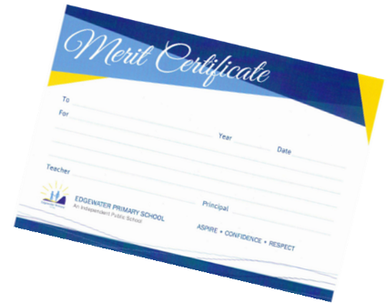

Merit Certificates
Merit Certificates are awarded to students by teachers for a variety of achievements, both academic and non-academic.
The certificates are presented at Friday assemblies. Parents/carers will be advised when their child is to receive a certificate and are invited to attend and join with the rest of the school in congratulating them.

Mobile Phones and Other Electronic Devices
We understand that some parents may wish to provide mobile phones to their children for safety or other reasons, but we are committed to protecting the safety of all students under our care and maintaining good order within our school. Not only is mobile phone usage disruptive, using cameras (still and video) to film other students and their activities without their knowledge and/or permission is an invasion of privacy. School is a safe space and this will not be tolerated.
This also applies to other electronic devices, which must not be brought to school. Students who wear smartwatches must ensure they are on Airplane Mode at all times.
Students are to leave their mobile phones at the office as soon as they arrive at school and collect them from the office at the end of the day. If parents wish to contact their child during the day with an urgent message, it can be left through the school office.
Students who do not follow these procedures will have their mobile phone confiscated and parents notified.

Money
Payment can be made direct to the school bank account using the details opposite. Please quote Student name, Room, Excursion Name as the reference. Alternatively, EFTPOS/credit card facilities are available at the school office. See Contributions/Charges for BSB and Account Information.
Music/Choir
Music lessons are provided to all students from Pre-primary to Year 6 by a specialist music teacher. The school has established junior and senior choirs for selected students, who from time to time, may perform at outside venues.

NAPLAN (National Assessment Program – Literacy and Numeracy)
Like all Australian schools, Year 3 and Year 5 students complete NAPLAN tests in Term 1. These online assessments give schools and parents/carers an indication of what students can do at that particular time, with special NAPLAN reports sent to parents later in the year.

Newsletters
The school newsletter is uploaded to the school website on the Friday of Weeks 4 and 8 of each term. Please ensure that we have your up-to-date email address on our system so we can send you an alert with links to our current newsletter.

No Hat, No Play
Students will not be permitted in the sun without wearing an approved school hat and they will be required to remain in the undercover area. An approved school hat is needed to participate in all Physical Education lessons and sport. Hats are of the bucket or Legionnaire’s style in royal blue. Bucket hats are available from our uniform supplier: Uniform Concepts at 5/7 Delage Street in Joondalup, or from the school office for $10. See details under Uniforms.

Office Opening Hours
The school office is open Monday to Friday from 7:30am to 3:30pm during the term, except for public holidays.

Out-oF-School-Care
Edgewater After School Care provide out–of–school-care (mornings and afternoons) for our students. Details can be obtained from the office.

P&C Association
Edgewater has a strong and active P&C Association. Read about its functions below.
Represent parents/community on school decision-making groups.

Encourage parents to participate in developing the school’s educational policy.

Be the forum for parents to discuss issues pertaining to the school and community for gathering opinions.

Provide extra amenities for the benefit of students.
Increase parent participation in the school.

Edgewater Primary School
P&C Association
Increase parent
participation in the school.

Promote and support communication and cooperation within the school community and to bring educational matters to the attention of the wider community.

(WACSSO P&C Handbook)

The P&C Voluntary Contribution has been set at $50 per family – or $12.50 per family per term from Kindergarten to Year 6 This is payable with the book list or through the school office.

Parent Involvement
Consistent, positive parental interest and involvement has a beneficial effect on students’ learning and behaviour. Parent help is welcomed in areas such as:
- Reading/Writing
- Art/Craft
- Maths
- Science
- Library
- Excursions
- Sport
Please ask your child’s teacher, or enquire at the school office, for further details.
It should be remembered that parent helpers must always observe confidentiality and any concerns should be raised with the teacher or Principal. Volunteers are required to fill out a Parent Declaration Form annually.

Parent/Teacher Interviews
Parent/Teacher interviews are held towards the end of Term 1 with bookings made through our online facility on the school website. This is an important time for parents and teachers to discuss student progress early in the year, allowing time for any interventions that may be required. All parents/carers are strongly encouraged to access this valuable opportunity to ensure that student achievement is maximised.

Parking
The utmost care is needed when setting down students in the morning, and especially when picking them up after school. Wet and very hot weather tends to increase congestion and inconsiderate parking. In turn, this increases the risk of an accident.
The school has a Kiss and Ride zone and marked parking bays at the front of the school. When using these, always look out for students. Do not park or stand in the Kiss and Drive as it is a flow-through area designed to limit congestion and move traffic in an orderly fashion at the beginning and end of the school day.
The school zone has a 40kph limit. There are additional marked parking bays at the back of the school in Kestrel Mews. The staff car parks must not be used for picking up and setting down students, or for changing direction on Treetop Avenue. Please use the roundabouts at Outlook Drive and Pioneer Drive for this purpose. Students are not permitted to walk or ride through either of the car parks.
Parents/carers are urged to exercise common sense, patience and consideration for the safety of all students.

Personal Use Items
Although the Department of Education supplies books and materials for students, some stationery and personal items are the responsibility of parents/carers. At the end of each year, students are given a list of requirements for the following year. Parents/carers are encouraged to participate in the school’s bulk-order process to ensure that items are of consistent quality and type. Naturally, they are free to purchase the requirements from other sources if they so choose. Throughout the school year it may be necessary to replenish supplies and teachers will advise parents/carers when this is necessary.
A copy of the Personal Items list can be downloaded from the school website.

Physical Education
All students from Pre-primary to Year 6 participate in a weekly hour-long physical education lesson conducted by our specialist physical education teacher. An approved school hat is required for all physical education lessons.

Pick Up Delays
Please advise your child to come to the school office if you are not able to arrive for a scheduled pick-up at the end of the day. We will then endeavour to phone either the parents/carers or the emergency contact. The school office will make every effort to get a message to students, but we cannot guarantee this, particularly if parents/carers are phoning towards the end of the day.

Play Equipment
For safety reasons, it is suggested that students do not use any outdoor playground equipment before or after school. After school the playground at the front of the school only if parents are supervising.

Playground Supervision
An adequate number of staff are rostered on playground supervision during recess and lunch to provide care of students. Whilst in the playground, teachers wear hi-visibility vests so that they are easily identified. Students are encouraged to report any problems to these teachers.

Psychologist (Student Welfare)
A school psychologist is on site one day per week. Their role is to provide support for students with academic, behavioural or emotional needs. Referrals to the School Psychologist are usually made by the classroom teacher who discusses any concerns with the Learning Support Team, comprising of the student’s ‘At Educational Risk’ Co-ordinator and the School Psychologist. After this consultation, a meeting may be arranged to decide the support that is required.
Parents who believe their child may benefit from the involvement of the school psychologist should direct their initial concerns to the classroom teacher.

Reporting to Parents
The school uses a reporting system that is both informative and helpful to parents/carers. This involves a combination of the Department of Education’s formal online reports, an open night and parent/teacher interviews. Two formal reports are provided each year electronically through Connect - one at the end of each semester.
By far the best method of reporting to parents is through face-to-face discussion. This can be done by contacting the office or the teacher directly to make an appointment for an interview. Parents/carers are urged to make personal informal contact with their child’s teacher regularly during the year, especially if there is a problem of any kind.
Alternatively, teachers will contact parents/carers if they wish to discuss their child’s progress.

Safety House Scheme
There is a well-established scheme coordinated by the P&C in Edgewater, whose objective is to act primarily as a deterrent to undesirable people coming into the area and approaching students whilst they are in transit to and from school. The Safety House Scheme identifies houses that are available for students to use if they feel unsafe whilst walking to or from school.
The scheme always needs new Safety Houses. Please contact the school office for further information or to check your eligibility to participate.

School Board
As an Independent Public School (IPS), we are required to have an effective school board that includes parent/carer, staff and community representation.
The Principal is responsible for the educational leadership and operational management of the school. To maximise the input of the school board in developing policies, the Principal seeks advice and receives recommendations from them.

The Edgewater Primary School Board consists of the following:
1 or 2 community representatives
(appointed by board)
6 – 7 elected parent/carer representatives
3 – 4 elected teaching staff
Principal
Principal

More information is available on our website.

School Grounds
After school hours, during weekends and on school holidays, no person is permitted on the school property without prior permission from the Principal. The Principal, members of staff, and Department of Education security officers, have the right to request people to leave the school grounds. Failure to comply could result in a prosecution for trespassing.
Parents/carers are asked to ensure that students do not come on to the school grounds out of hours. The school oval is exempted. However, bikes, dogs and golf are not permitted on the oval at any time.

School Nurse
The school is serviced by nurses from Health Department. A school nurse is available for routine testing and to conduct health assessments of Pre-primary and Kindergarten students.

School Photos
All students are photographed by our nominated school photography company. No-obligation package deals are sent home to parents/carers at the appropriate time.

School BEHAVIOUR EXPECTATIONS
The school behaviour expectations reflect the school’s Supporting Positive Behaviour policy. The following expectations are for the benefit and safety of all students. Parental cooperation is requested and appreciated.
Students will…
Always move around the school during class time in a quiet and orderly manner.

Stay within their designated play areas and the school boundaries.

Wear hats in the sun at all times.

Stay out of the classroom if a teacher is not in the room.

Show respect for their own and other people’s property.

Always behave in a courteous and respectful manner towards all others in the school community.

Only leave the school grounds during school hours with the permission of the school.

Security - School Watch
The school is equipped with a 24-hour monitoring system and mobile security guards make frequent visits to the school out of hours. The Department of Education has installed a Freecall 1800 number as part of the School Watch Program. This service is available throughout the state to members of the community who may witness suspicious activity occurring around schools after hours. For details, see the last page of this booklet.

Signing Out
A student’s parent/carer must report to the office to provide details before a student is permitted to leave the school grounds. Notifying the office of an early pick up and time is advised. The student can be waiting in the office for collection.

Smoking/Vaping
All public schools are Smoke Free Zones and smoking is not permitted anywhere in the school grounds, including the oval. Your cooperation in protecting the health of our students and staff is appreciated.

Special School Programmes
The Department of Education arranges Primary Extension & Challenge (PEAC) programs designed to cater for students in Years 5 and 6 who are identified as gifted and talented from state-wide testing in Year 4. These courses are held off-site and coordinated by the Yaluma PEAC Centre. Their website is https://www.northmetropeac.wa.edu.au/. You can also access this link on our school website. Parents/carers of students who have been identified will be provided with details on how to enrol.
An Early Years’ Extension Programme is available to selected students in Years 1, 2 and 3. The school is fortunate to have available lessons in both clarinet and classical guitar provided by the Department of Education’s Instrumental Music School Service (IMSS). Students from Year 5 and 6 are chosen for these lessons following a rigorous identification programme in Year 4.

Sports and Faction Athletics Carnival
The school encourages physical exercise and participation in sporting activities, not only within the school, but at the interschool level.
Each year the school holds a Faction Sports Carnival with the date indicated on our website. Parents/carers and families are welcome to attend and support their children and their faction. It has become traditional for parents/carers to bring a picnic lunch to share with their children. The school canteen provides a wide variety of food and beverage items for purchase.
During the year many of our students participate in interschool athletics, cross country carnivals, and interschool sports.

Student Assessment and Evaluation

This is an ongoing process that involves both the student and the parent/carer. It takes a variety of forms and will be both formal and informal. Further details regarding the reporting process will be provided throughout the year in consultation with parents. See Reporting to Parents.

Student Council and Faction Captains
Following a nomination and voting procedure, students are elected to the student council or to act as faction captains.

Student Leadership
The school has developed a strong student leadership programme. The model that is used ensures that students develop leadership skills that will assist them both now and in the future.

Swimming Lessons
During the year, all students from Pre-primary to Year 6 are eligible to participate in a series of in-term swimming lessons provided by the Department of Education. The timing of these lessons varies from year to year and information is provided via the school newsletter. There are associated costs for bus transport and pool entry, but there is no charge for the lessons.

Telephone Messages
In a large school, personal telephone calls and messages for students can tie up the precious time of office staff. Please limit such calls to emergency situations only.

Term Planner
A term planner is available via Compass, including week-by-week events. This planner is regulary updated to ensure that it accurately reflects all school events.

Transfers to and from other Schools
When a child transfers from one school to another, an admission card must be completed at the new school. The admitting school advises the former school when admission has been effected. However, parents are asked to notify both schools well in advance, where it is possible to do so. The student’s workbooks and personal effects should be collected and taken to the new school. Please ensure that such items as reading books and library books that belong to the former school are returned. Student records are sent directly to the new school.

Uniforms
Edgewater Primary School has a school dress code policy which has been established in consultation with staff and parent representatives. This code is strongly supported by the School Board and P&C Association. The school’s uniform colours are gold and royal blue.
We always encourage the wearing of the uniform by students. School hats are compulsory when playing outdoors in accordance with our ‘No hat, No play’ school policy. Students who are not wearing a hat must remain in a designated shaded area. School hats are available for purchase from the school office for $10 or from our uniform supplier.
A comprehensive information sheet is available from the school office providing details of the uniform requirements and purchasing arrangements through Uniform Concepts, an off-site supplier. A price list is available on our website.
Second hand uniforms can be purchased for a gold coin donation. These are kept in the atrium area near the office.
Parents/carers should remind their children that school hats must always be worn during the year. Note that sun visors are not suitable.
Please ensure that each item of children’s clothing and other property brought to school is clearly marked with their name, so that items can be easily identified if mislaid.
Uniform Concepts
5/7 Delage Street Joondalup
Phone: 9270 4660

Visitors
All visitors to the school are required to sign in at the office and receive an identification badge. Parents/carers coming onto school grounds between 9:00am and 2:30pm are to report to the school office to sign in and obtain identification before moving around the school. This is an important security measure, especially in cases where there is an emergency evacuation.

Website
The school website – www.edgewaterps.com.au – provides information about the school and its operations. It is updated on a regular basis along with the school app, Compass.

NUMBERS
POLICE ASSISTANCE
NUMBER
13 14 44
School Watch
Freecall number
1800 177 777
Getting Involved!
Parents as Partners
Involvement in school by parents and carers helps children achieve the best possible learning outcomes. At Edgewater you are encouraged to participate in school life, both formally and informally, through the Parents and Citizens’ Association, the School Board, helping in the classroom or volunteering.
Students and staff enjoy the company of parents and friends at school assemblies, sports days, open days/nights, musical events as well as other activities. Your involvement in these activities helps students feel positive about themselves, our school and their place within our school community.

getting involved

school map

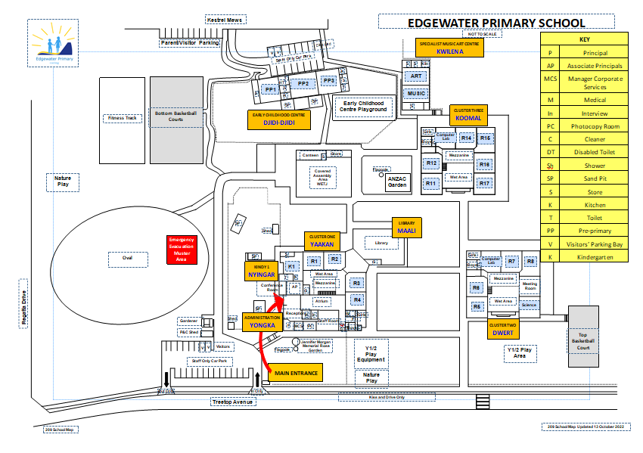

check list
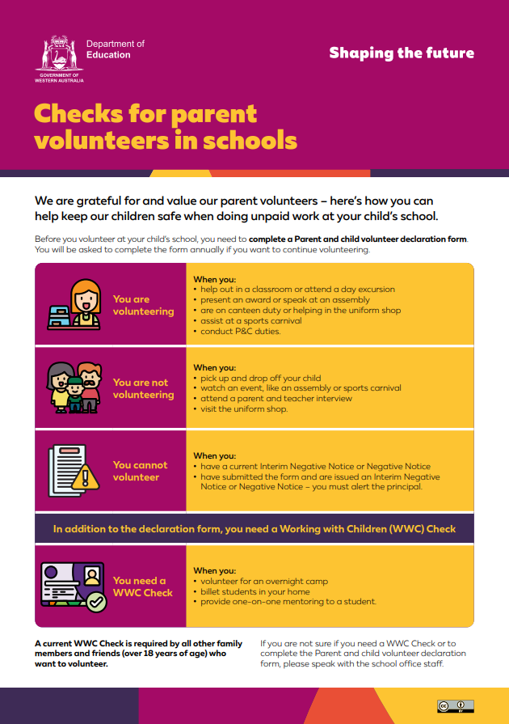

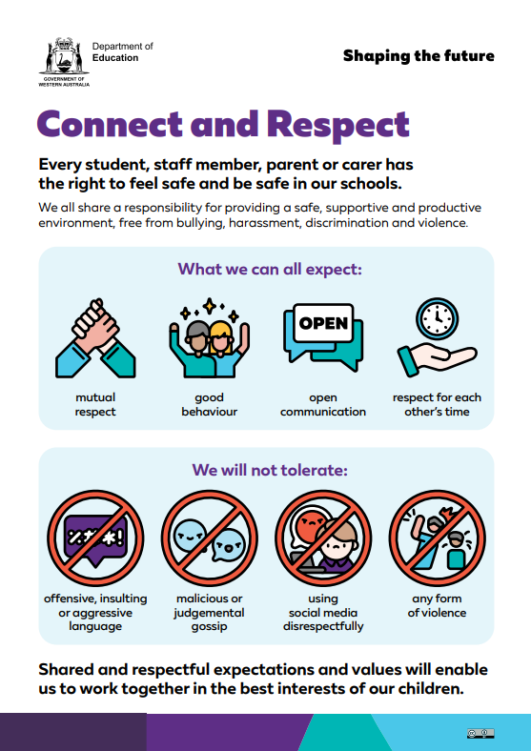

Treetop Avenue Edgewater WA 6027
(08) 6207 3200
edgewater.ps@education.wa.edu.au
www.edgewaterps.wa.edu.au
EDGEWATER PRIMARY SCHOOL

An Independent Public School

